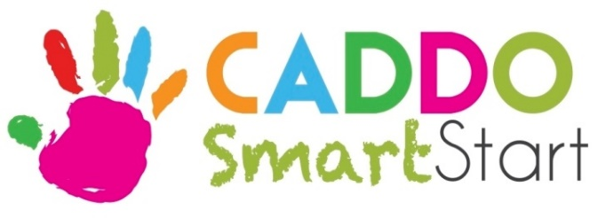

Why do I complete an Early Childhood on-line application?

- I am looking for an Infant, Toddler or PreK program for my child

Where do I find early childhood programs?

- Type III Child Care Centers, Early Head Start, Head Start, Public and Charter Schools

What do I need to complete an Early Childhood on-line application?

- Child’s Certified Birth Certificate
- Child’s Social Security Card
- Child’s Louisiana Immunization Record
- Parent/Legal Guardian State Issued Photo ID
- Parent/Legal Guardian Proof of Residence (a current utility bill (gas, water or electric only OR a current lease or mortgage statement with parent/legal guardian name and address)
- Parent/Legal Guardian Proof of Income (2 consecutive check stubs within 2 months of application for each parent/legal guardian in the home) OR Benefits Letter from SNAP

What else do I need?

- Child’s full name and date of birth
- Number of adults in the household
- Number of children in the household
- Monthly income of each parent/legal guardian in the household
- My decision of my 1st, 2nd and 3rd choice of early childhood program

What if I need help?

- Call or go to my 1st choice program
- Examples:
- If a Public/Charter School PreK program is my first choice, then I can go to that School for help in completing the on-line application
- If an Early Head Start/Head Start program is my first choice, then I can go to that Early Head Start/Head Start for help in completing the on-line application
- If a Child Care Center is my first choice, then I can go to that Child Care Center for help in completing the on-line application

